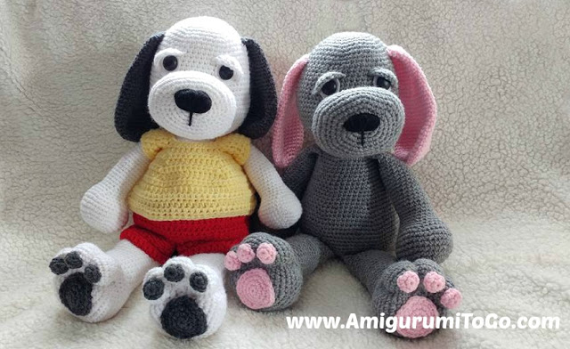

Abbreviations:
st = stitch
sc = single crochet
ch1 = chain one
sl st = slip stitch
2tog = crochet 2 stitches together
BLO = back loops only
FLO = front loops only
f/o = finish off
How to read the rows: Each row has a sequence as given below. Example: 1sc then 2sc in next st means repeat that sequence 1sc then 2sc in next st followed by 1sc then 2sc in next st over and over to the end of that particular row. The number inside the parentheses ( ~ ) is the number of stitches you should have at the end of that particular row.
EYES: Placements are up to you since it's personal preference. I put the white puppy's eyes in between the 15th and 16th row, and the grey puppy eyes are in between the 16th and 17th. Both have about 9 visible stitch holes between them. (I counted the stitch holes under the felt piece).
If you plan on making a patch for the one eye, then just attach the one eye. The 2nd eye gets attached to the patch itself and that is sewn on after the puppy is stuffed and closed. See assembly instructions, link to assembly page is at the bottom of this pattern.
Starting at the top of the head working down to bottom of body:
1) magic circle with 6sc (6)
2) 2sc in each st (12) = prevod: 2sc v vsak st (12)
3) 1sc in next 2sc in next st (18) = prevod: 1sc nato 2sc v naslednji st
4) 1sc in next 2st then 2sc in next st (24) = prevod: 1ac v naslednja 2sc nato 2sc v naslednji st
5) 1sc in next 3st then 2sc in next st (30)
6) 1sc in next 4st then 2sc in next st (36)
7) 1sc in next 5st then 2sc in next st (42)
8) 1sc in next 6st then 2sc in next st (48)
9) 1sc in next 7st then 2sc in next st (54)
10-15) 1sc in each st for 6 rows = prevod: 1sc v vsak st naslednjih 6 vrst
16) 1sc in next 8st then 2sc in next st (60)
17) 1sc in each st for 1 row
18) 1sc in next 9st then 2sc in next st (66)
19-25) 1sc in each st for 7 rows
add the safety eyes before you continue on = vstavi oči
26) 1sc in next 9st then 2tog (60) = prevod: 1sc v naslednjih 9st nato 2st skupaj
27) 1sc in each st for 1 row
28) 1sc in next 8st then 2tog (54)
29) 1sc in next 7st then 2tog (48)
30) 1sc in next 6st then 2tog 42)
31) 1sc in next 5st then 2tog (36)
32) 1sc in next 4st then 2tog (30)
33) 1sc in next 3st then 2tog (24)
34) 1sc in next 2st then 2tog (18)
Naslednja vrstica bo mogoče malo nerodna za kvačkati vendar bo kvačkanje lažje ko se bo trup večal.
35) 1sc in next 2st then 2sc in next st (24)
Napolni večino glave. Polnilo potisni čisto do vrha glace. Glej da bo polnilo tudi ob straneh glave in vratu. Med polnjenjem oblikuj glavo. Potreboval boš veliko polnila. Ponovno boš polnič čez nekaj vrstic.
36) 1sc in next 3st then 2sc in next st (30)
37) 1sc in next 4st then 2sc in next st (36)
Ponovno polni glavo, v koliko je to potrebno. Poskrbi, da bodo morebitne luknje zapolnjene38) 1sc in next 5st then 2sc in next st (42)
39-43) 1sc in each st for 5 rows
44) 1sc in next 6st then 2sc in next st (48)
45) 1sc in next 7st then 2sc in next st (54)
46-48) 1sc in each st for 3 rows
49) 1sc in next 8st then 2sc in next st (60)
50) 1sc in next 9st then 2sc in next st (66)
51) 1sc in next 10st then 2sc in next st (72)
52) 1sc in each st for 1 row
53) 1sc in next 11st then 2sc in next st (78)
54) 1sc in next 12st then 2sc in next st (84)
55-59) 1sc in each st for 5 rows
60) 1sc in next 12st then 2tog (78) = prevod: 1sc v naslednjih 12st nato 2 skupaj
61) 1sc in next 11st then 2tog (72)
62) 1sc in next 10st then 2tog (66)
63) 1sc in next 9st then 2tog (60)
64) 1sc in next 8st then 2tog (54)
65) 1sc in next 7st then 2tog (48)
66) 1sc in next 6st then 2tog (42)
67) 1sc in next 5st then 2tog (36)
Napolni večino trupa. Posebno poskrbi, da bo dovolj polnil v vratu!
68) 1sc in next 4st then 2tog (30)
69) 1sc in next 3st then 2tog (24)
Ponovno polni telo. Oblikuj med polnjenjem.
70) 1sc in next 2st then 2tog (18)
Še malo polni, oblikuj telo, trebuh naj bo zaobljen in gladek.
71) 1sc then 2tog (12)
72) 1sc in next 4st then 2tog (10)
zaključi (f/o) in pusti dovolj preje za zapiranje odprtine. Preostale st prepleti skupaj. Če je potrebno še dodaj polnilo nato zatisni prjo in odprtino. Ostanek preje zavozljaj in skrij v telo. Weave in and out of the remaining stitches.
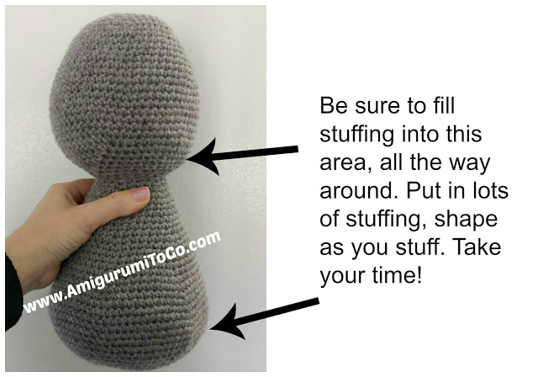
Muzzle:
1) magic circle with 6st (6) No need to pull the center hole too tight as you will go through this hole when you whip stitch the nose in.
2) 2sc in each st around (12)
3) 1sc then 2sc in the next st (18)
4) 1sc in next 2st then 2sc in next st (24)
5) 1sc in next 3st then 2sc in next st (30)
6) 1sc in next 4st then 2sc in next st (36)
7) 1sc in next 5st then 2sc in next st (42)
8) 1sc in next 7st, 3sc in next st, 1sc in next 2st, 3sc in next st, 1sc in next 2st, 3sc in next st, 1sc in next 14st, 3sc in next st, 1sc in next 2st, 3sc in next st, 1sc in next 2st, 3sc in next st, 1sc in next 7st (54)
9-12) 1sc in each st for 4 rows
13) 1sc in next 7st then 2tog (48)
14) 1sc in next 6st then 2tog (42)
15) 1sc in next 5st then 2tog (36)
16) 1sc in each st for 1 row
sl st next st and f/o leaving a long tail for sewing.
See the assembly page here for how to stitch the nose in.
Ears: If you would like to make the ears a bit shorter then eliminate a few rows between 24 and 31
1) magic circle with 6sc (6)
2) 2sc in each st (12)
3) 1sc then 2sc in the next st (18)
4) 1sc in next 2st then 2sc in next st (24)
5) 1sc in next 3st then 2sc in next st (30)
6) 1sc in each st for 1 row
7) 1sc in next 9st then 2sc in next st (33)
8) 1sc in each st for 1 row
9) 1sc in next 10st then 2sc in next st (36)
10) 1sc in each st for 1 row
11) 1sc in next 10st then 2tog (33)
12-13) 1sc in each st for 2 rows
14) 1sc in next 9st then 2tog (30)
15-16) 1sc in each st for 2 rows
17) 1sc in next 8st then 2tog (27)
18-19) 1sc in each st for 2 rows
20) 1sc in next 7st then 2tog (24)
21-22) 1sc in each st for 2 rows
23) 1sc in next 6st then 2tog (21)
24-31) 1sc in each st for 8 rows
32) do not stuff, fold ear flat and sc through both sides across.
f/o leaving a tail for sewing.
Arms:
1) magic circle with 6sc (6)
2) 2sc in each st (12)
3) 1sc then 2sc in next st (18)
4) 1sc in next 2st then 2sc in next st (24)
5) 1sc in next 3st then 2sc in next st (30)
6) 1sc in next 4st then 2sc in next st (36)
7-10) 1sc in each st for 4 rows
11) 1sc in next 4st then 2tog (30)
12) 1sc in next 3st then 2tog (24)
13) 1sc in each st for 1 row
14) 1sc in next 4st then 2tog (20)
15-35) 1sc in each st for 21 rows
stuff hand once you got 5 rows done. Stuff arm as you go. Leave the last 6 rows unstuffed.
36) fold top of arm flat and sc through both sides across. f/o leaving a long tail for sewing.
Legs:
1) magic circle with 6sc (6)
2) 2sc in each st (12)
3) 1sc then 2sc in next st (18)
4) 1sc in next 2st then 2sc in next st (24)
5) 1sc in next 3st then 2sc in next st (30)
6) 1sc in next 4st then 2sc in next st (36)
7) 1sc in next 5st then 2sc in next st (42)
8) 1sc in next 6st then 2sc in next st (48)
9-12) 1sc in each st for 4rows
13) 1sc in next 6st then 2tog (42)
14) 1sc in next 5st then 2tog (36)
15) 1sc in next 4st then 2tog (30)
16) 1sc in next 8st then 2tog (27)
17-36) 1sc in each st for 20 rows
stuff foot after you get 5 rows done. It'll take lots of stuffing. Stuff leg as you go along, leave the last 3 or 4 rows unstuffed. When you stuff the foot, push the stuffing into the sides to shape it, also stuff towards what will be the heel of the foot, this is important for shaping. The middle circle or row 1 should be up higher, towards the top of the foot when you're done. See photos below.
37) Depending on where the last stitch of the last row ended you will have to sc around until you reach the side of the leg. The leg will look twisted if you don't get to the side, it's easier to sc to the side then have to play around with the shape after you close up the leg.
Fold flat then sc through both sides of the leg across.
38) ch1 turn, skip ch and put 1sc in each st across.
f/o leaving a tail for sewing.
How to make the toes is shown in the ASSEMBLY section. See bottom of page for link.
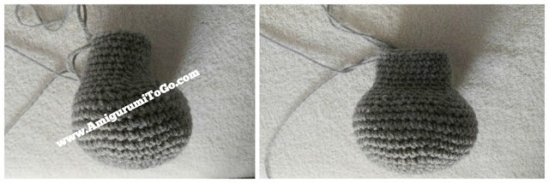
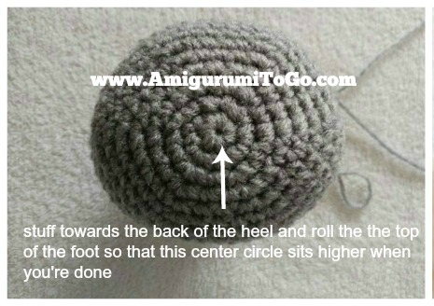
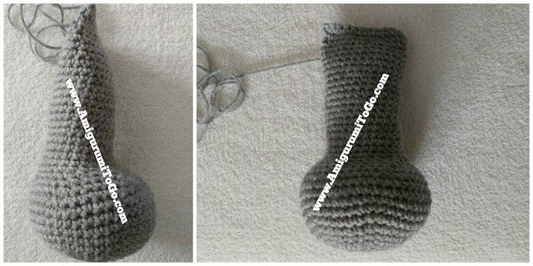
Smaller Foot Pads: Make 3 per foot
1) magic circle with 6sc (6)
2) 1sc then 2sc in next st (9)
sl st next st and f/o leaving a tail for sewing. Make 3 per foot
Larger Foot Pads: Make 1 per foot
1) magic circle with 6sc (6)
2) 2sc in each st (12)
3) 1sc then 2sc in next st (18)
4) 1sc in next 2st, 2sc in next 2st, 1sc in next 10st, 2sc in next 2st, 1sc in next 2st (22)
sl st next st and f/o leaving a tail for sewing. Make 1 per foot
Eye Patch: Optional ~ you can leave this off.
1) magic circle with 6sc (6)
2) 3sc in first st, 1sc in next 2st, 3sc in next st, 1sc in next 2st (10)
3) 1sc then 2sc in next st (15)
4) 1sc in next 4st then 2sc in next st (18)
5) 1sc in next 2st then 2sc in next st (24)
sl st next st and f/o leaving a tail for sewing.
note: the patch looks bigger in the video as I had added 1 more row, later I decided to remove that row.
Eye lids: If you use the eye patch then make one in body color and one same color as eye patch. If you do not use the eye patch then make 2 the same color as the body.
1) ch8 starting tail should be long enough to sew into head.
2) starting in 2nd ch from hook, 1sc in each ch (7) turn, don't ch1
3) skip first st, 1hdc in next st, 2dc in next 2st, 1hdc in next 2st, sl st last st
f/o leaving a tail for sewing
Tail:
1) magic circle with 6sc (6)
2) 1sc then 2sc in next st (9)
3-4) 1sc in each st for 2 rows
5) 1sc in next 2st then 2sc in next st (12)
6-22) 1sc in each st for 17 rows stuff as you go, leaving the last 2 or 3 rows unstuffed.
23) fold top of tail flat and sc through both sides across.
f/o leaving a tail for sewing.

